Faith Formation Auburn & Cayuga County Parishes Sacrament of First Penance

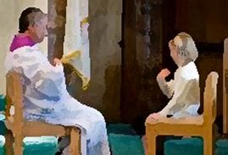

**Sep 21 You are Blessed**

**Oct 5 The Best Version of Yourself God Sent Jesus to Save Us**

**Nov 2 Forgiving and Healing**

**Dec 7 First Penance Rehearsal**

**Dec 14 First Penance**

***Then He said..., “Your sins have been forgiven.” Go and sin no more.”*** Luke 7:48

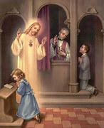

*All classes will be held at St. Marys Church Basement in Schrader Hall. Classes start promptly on Saturday’s at 9:00 AM and will end at 10:30 AM. Catechists Mr. Jon Robson and Mrs. Debbie Lovell* **(Questions can be directed to Deacon Gary DiLallo at 315-252-7593 or** [**Gary.DiLallo@dor.org**](mailto:Gary.DiLallo@dor.org))